**A Project Report**

**On**

**Chat Application (Chat Vista)**

**Submitted by**

**BALRAM SAVITA, 2115000282**

**JAYANT CHAUDHARY, 2115000496**

**KARTIKEY VARSHNEY, 2115000521**

**SANJYOTI SINGH, 2115000911**

**Supervisor**

**Mr. Brajesh Kumar**

**Faculty**

**Coding Blocks**

**Department of Computer Engineering &Application**

**G.L.A. UNIVERSITY**



**GLA University, Mathura - 281406**

**24/11/2023**

**BONAFIDE CERTIFICATE**

Certified that this project report “**Chat – Vista**” the chat application is the bonafide work of “Balram Savita (2115000282), Jayant Chaudhary (2115000496), Kartikey Varshney (2115000521) and Sanjyoti Singh (2115000911)” who carried out the project work under my supervision.

**SIGNATURE (HOD) SIGNATURE(SUPERVISOR)**

**Dr. Rohit Agrawal Mr. Brajesh Kumar**

**HEAD OF THE DEPARTMENT (Coding Blocks)**

**CSE Department** **CSE Department**



# ACKNOWLEDGEMENT

It gives us the immense pleasure to present the report of the B.Tech. Mini Project undertaken during B.Tech. 3rd Year. This project would never have seen the light of the day without the help and guidance that we have received.

Our heartiest thanks to **Mr. Brajesh Kumar, Supervisor (Coding Blocks)** for providing us with an encouraging platform to develop this project, which thus helped us in shaping our abilities towards a constructive goal.

We owe special debt of gratitude to him for his constant support and guidance throughout the course of our work. He has showered us with all his extensively experienced ideas and has also taught us about the latest industry-oriented technologies.

We also do not like to miss the opportunity to acknowledge the contribution of all faculty members of the department for their kind guidance and cooperation during the development of our project.

**BALRAM SAVITA (2115000282)**

**JAYANT CHAUDHARY (2115000496)**

**KARTIKEY VARSHNEY (2115000521)**

**SANJYOTI SINGH (2115000911)**



**TABLE OF CONTENTS**

**List of Figures Abstract Graphic**

**Chapter 1. Introduction**

* 1. Identification of relevant Contemporary issue
  2. Identification of Problem
  3. Identification of Tasks
  4. Timeline

**Chapter 2**. **Goals and Objectives**

* 1. Problem Statement
  2. Goals and Objectives

**Chapter 3. Design Flow**

* 1. Hardware & Software Requirements
  2. Project Design

**Chapter 4. Implementation & Validation**

4.1 Implementation

**Chapter 5. Conclusion And Future Work**

* 1. Conclusion
  2. Future Work

**References**

# List of Figures

Figure 3.1 Header

Figure 3.2 Sign up

Figure 3.3 Sign in

Figure 3.4 Get Started

Figure 3.5 Log out

# ABSTRACT

Full Stack Development is the ability to develop websites and user-friendly web applications with fully functional backend facilities. After learning Html, CSS, Java-script, NodeJS, EJS and MongoDB we made up a website for allowing users all across the globe to chat. They all can chat; it is like a global chat box where anyone can join at any time irrespective of location.

**Chat Vista** will be an application where user can chat easily on daily basis and could get acknowledged by other users too. They can as well suggest their friends to join. As we all know today’s world is connected, and we need to stay connected for daily updates.

With this idea in our thoughts, we chose **Chat Application** as our mini project and hope we shall be successful in accomplishing it.



**CHAPTER 1 INTRODUCTION**

* 1. **Identification of relevant Contemporary issue**
     + This is no one-on-one chatting application. It is a global chat application.
     + The website is not responsive.
     + There are multiple chatting applications in competition.
     + Major IT Companies have their own platform to showcase their daily achievements on an authenticated web application.
  2. **Identification of Problem**

Need For Authentic Secure Platform To display Chat application and provide User Interface for our clients and users to access content.

* 1. **Identification of Tasks**

There are several tasks that need to be performed:

* Gathering of all requirements and features required in the website
* Analyzing requirements and feasibility study
* Planning and creating appropriate model
* Making initial design of website
* Implementation of Design and Coding
* Testing of website
* Error Detection and Handling
  1. **Timeline**

November 1-10 Requirement Specification, Built up Model April November 1-10 Designing of Website and User Interface April November 11-15 Implementation started. Built Apps and website. November 16-22 Completed Project. Testing. User Review.

November 23-29 Project Presentation and Report Submission.

**CHAPTER 2**

**GOALS AND OBJECTIVES**

* 1. **Problem Statement**

A website having authentication, header and get started page required.

* 1. **Goals and Objectives**

There are several goals:

* + 1. A Website to display the journals.
    2. User Friendly User Interface.
    3. Secure Platform
    4. Free to Use.

**CHAPTER 3 DESIGN FLOW**

* 1. **Hardware & Software Requirements**
     + HTML, CSS and JAVASCRIPT
     + VS CODE
     + Google Firebase
     + NodeJS, EJS and MongoDB
     + Version Control and Hosting: GitHub
     + Processor: i5 or above
     + Minimum 4GB RAM
     + Windows Operating System
  2. **Project Design**

The website has various sections such as: -

1. Header
2. Profile
3. Login
4. Sign up
5. Log out

The roles of the sections are as follows:

**Header:** This contains our Chat Vista, Login, Signup.

A header is the top margin of each page, and a footer is the bottom margin of each page. Headers and footers are useful for including material that you want to appear on every page of a document such as your name, the title of the document, or page numbers.



Fig 3.1 Header image

The Chat Vista symbol if the user clicks on it he redirects himself to the home page.

**Sign in :** A login page is a page on a website or app that requires users to enter their login credentials in order to access the site's content or features. Typically, a login page will prompt the user to enter their username or email address, followed by their password.

Creating an effective login page is important for ensuring the security of your website or app. You can use tools such as two-factor authentication or captcha to further enhance security and prevent unauthorized access.

To create a user-friendly login page, it's important to ensure that the design is clear and simple, with easy-to-follow instructions and error messages. You can also offer users the ability to reset their password or retrieve their username if they have forgotten it.

Overall, a well-designed login page can help ensure that your website or app is secure and easy to use, enhancing the user experience and encouraging users to return to your site or app. By prioritizing security and ease of use, you can create a login page that meets the needs of both you and your users.

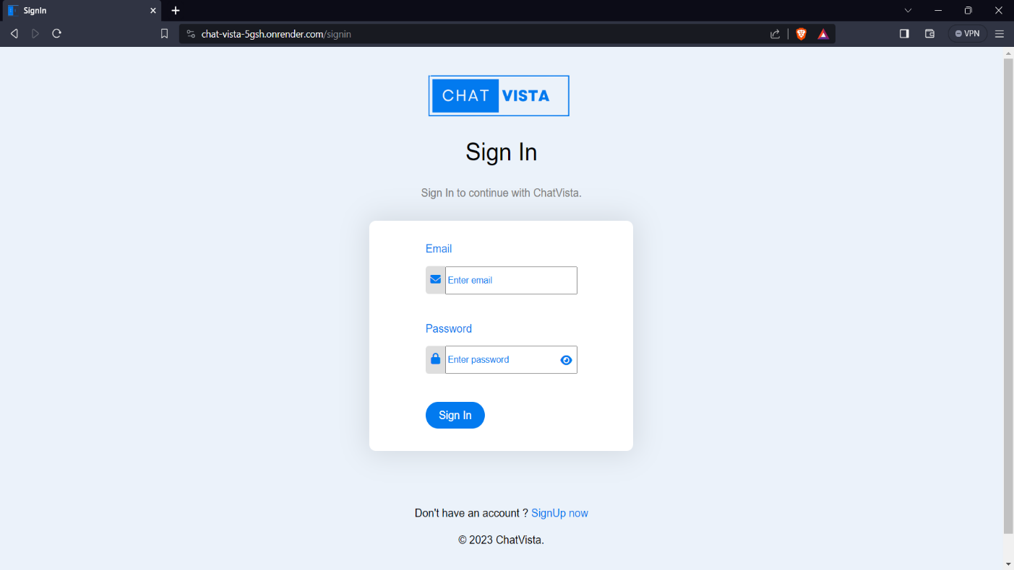

Fig 3.2 Sign in Page

**Sign Up:** A sign-up page is a page on a website or app that allows users to create a new account. Typically, a sign-up page will prompt the user to enter their personal information, such as their name, email address, and password, followed by any additional information that may be required for registration.

Creating an effective sign-up page is important for ensuring a smooth user experience and encouraging users to create an account. To achieve this, it's important to ensure that the sign-up page is easy to use, with clear instructions and minimal required information.

You can also use tools such as email verification or captcha to enhance security and prevent spam accounts. Additionally, you can offer users the ability to sign up using their social media accounts, making the process even more streamlined and convenient.

Overall, a well-designed sign-up page can help attract and retain users on your website or app, providing them with a simple and easy way to create an account and begin using your platform. By prioritizing user experience and security, you can create a sign-up page that meets the needs of both you and your users.

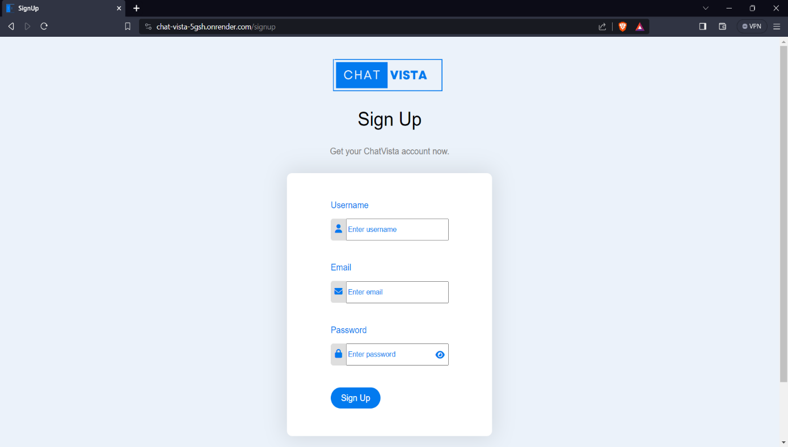

Fig 3.3 Sign Up page

**Get Started page:** After login the user clicks on get started and the user is relocated on the chatting page directly.

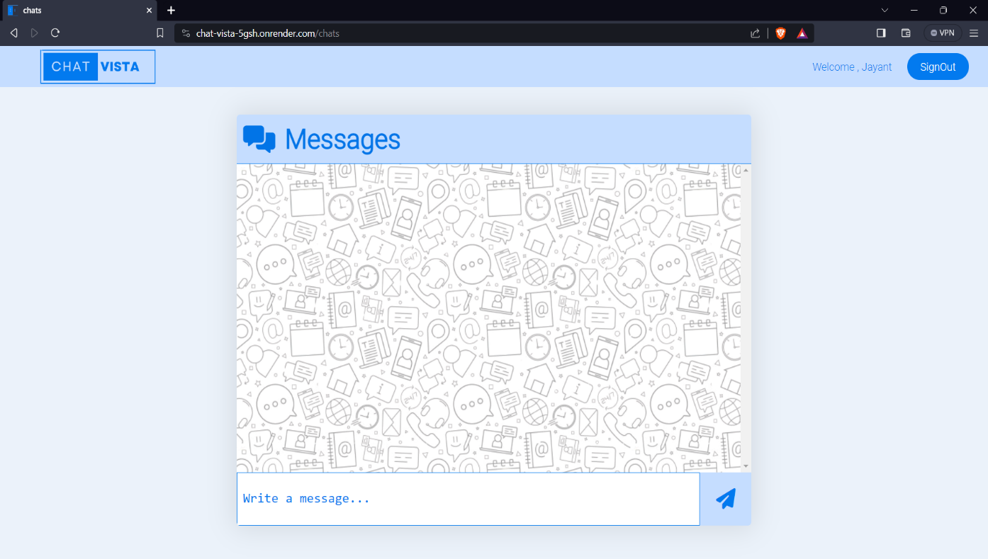

Fig 3.4 Chatting page

**Log out:** A log out button is a feature on a website or app that allows users to securely log out of their account. This button is typically located in the user interface and can be accessed from any page on the site or app.

Implementing a log out button is an important security measure, as it ensures that users can protect their personal information and prevent unauthorized access to their account. It also helps ensure that users do not accidentally leave their account open on a shared device or public computer.

To create an effective log out button, it's important to ensure that it is prominently displayed and easy to access, with clear instructions for use. You can also offer users the option to stay logged in for a certain amount of time, such as a week or month, before requiring them to log in again.

Overall, a well-designed log out button can help ensure the security of your website or app, providing users with an easy and secure way to log out of their account when they are finished using it. By prioritizing security and user experience, you can create a log out button that meets the needs of both you and your users.

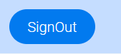

Fig 3.5 Sign out image

**CHAPTER 4 IMPLEMENTATION AND VALIDATION**

**4.1 Implementation**

* In this project “Chat Application – Chat Vista”, We used multiple technologies. These technologies are as follows: -
* 1)For Frontend – HTML, CSS, JavaScript
* 2). For Backend – Nodejs, express, socket.io, MongoDB, JWT
* In Frontend we used technologies HTML, CSS, JavaScript which are the expressing elements in our website we designed how our website would look and it’s basic working.
* In Backend we used technologies like Nodejs, MongoDB, socket.io, express which are used working and connection how our application will work without any issue.
* The main motive of this project to understand how the basics are very important in any website and how does a chat application work. We created a application which is a universal chat box. Anybody can join us just by sign in and become the part of this. It as well gives clear idea what issues a programmer can encounter while programming.
* Our main objective is that this application is going to help people to connect to each other via text messaging.
* We created a sample frame(frontend) using html, css, javascript.
* We created all the pages required (main page, sign in page, sign up page and chat page) and connected them using html and designed the pages according to us with help of css. We as well used the javascript.
* At the backend we used multiple technologies as mentioned above. The basic working included nodejs which included framework of the application, MongoDB is used to create the database which will hold the data like gmail id’s and password’s to login and it will be working as the verification system for logging in the chat application.
* We used JWT tokens for creating a cookie to find out if user is still logged in or not.

**CHAPTER 5 CONCLUSION AND FUTURE WORK**

**5.1. Conclusion**

We are doing this project to understanding the working of a chat application from the very basic level and it is the usage of our knowledge so far. We learned what are some of the issues a programmer faces while making a website which need to go public and used in this particular way. It was a good experience to work the basics and face down the issues with the help of our mentor.

**5.2. Future work**

Apps need updates and maintenance for improvement.



**Bibliography/ References**

* Used Canva for the designing of the logo (Chat - Vista).
* YouTube: <https://www.youtube.com/watch?v=tWy3BX8GQXU&list=PLQDioScEMUhlBbHLB_uJ0QxuMkS0Pz8m9&index=3&ab_channel=ProgrammingExperience>
* Referenced images used in website from google.